Task 9
Practice task
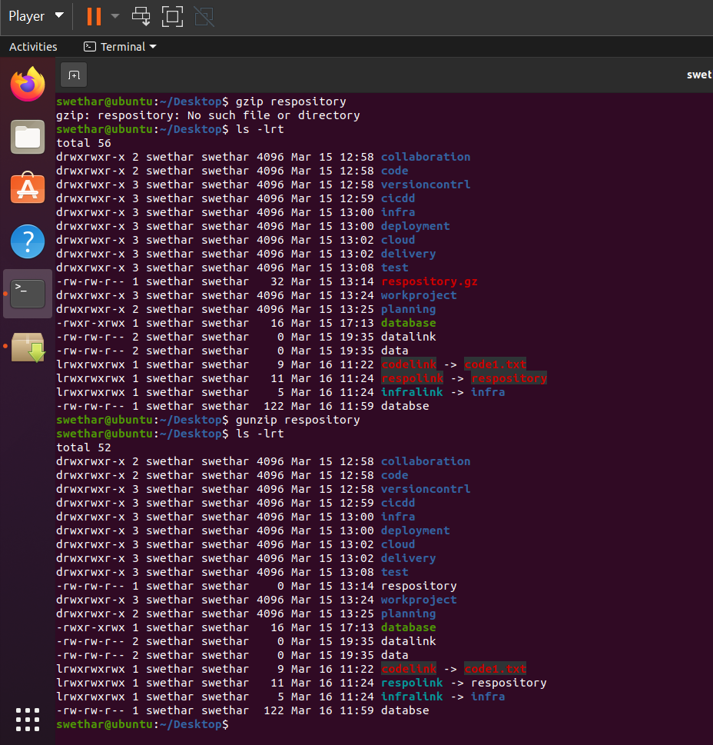
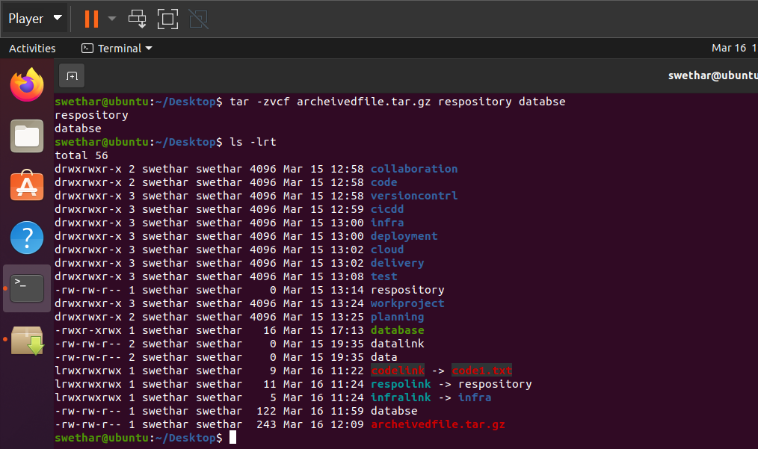

Additional task
1. How to display the first and last column of each line on the terminal using AWK
awk '{print $1,$NF}' file.txt
2. How to display the line number followed by last column content of a file using AWK?
awk '{print NR,$NF}' file.txt
3. What does awk '{print NR,$0}' <file-name> command will do?
awk '{print NR,$0}' file.txt
It prints each line with its line number.
5. How to compress multiple files
tar -czvf files.tar.gz file1 file2 file3
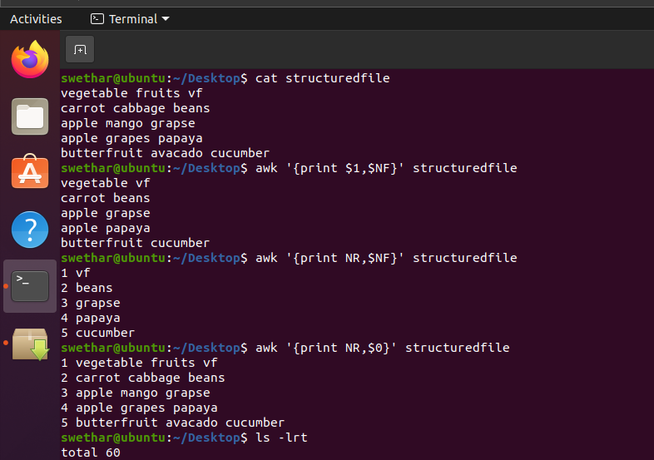
4. How do you check the contents of a .tar.gz archive file without extracting it?
Hint: tar -tzvf rk123.tar.gz

